Thematic Module Title

OVERVIEW 2
MENTAL MAP 3
TEACHERS INVOLVED 3
UNIT 1 4
LESSON 1 4
LESSON 2 4
QUIZ 4
UNIT 2 5
LESSON 1 5
LESSON 2 5
QUIZ 5

OVERVIEW

MENTAL MAP
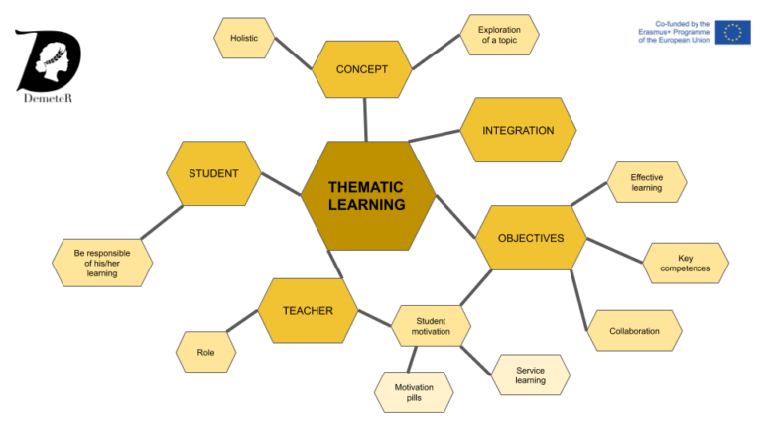<thematic module title> mental map

TEACHERS INVOLVED

NAME OF THE TEACHER
Brief curriculum. 5 lines.

UNIT 1
Description of the unit:

LESSON 1
Content of the lesson 1

LESSON 2
Content of the lesson 2

QUIZ
Purpose of the quiz.

question 1
Single-choice
What is the most beautiful city in Spain?
- Barcelona
- Valencia
* Estepona

question 2
Multichoice
What are the partners of the DEMETER project?
- Finland
* Sweden
* France
- Germany
* Croatia
* Spain

question 3
True/false
ICAROS project was previous to DEMETER project?
* True
False

…..

UNIT 2
Description of the unit:

LESSON 1
Content of the lesson 1

LESSON 2
Content of the lesson 2

QUIZ
Purpose of the quiz.

question 1
answer/answers

question 2
answer/answers
…..

IMPORTANT

Platform
Use Google Docs. Juan Carlos Moreno (jmorper037@maralboran.es) will share a copy of the template to work on it.

Teachers involved
Include a picture of the teachers with a brief description of his/her curriculum, position, etc.

QUIZZES
Kind of quizzes:
- True/false
- Single-choice
- Multichoice

PICTURES
Every picture has a footer. Example:
Picture1: Description of the picture.

Files of the pictures distributed in a zip file apart of the document.

Format:
- Only JPG or PNG
Name of the pictures:
MENTAL MAP | MENTAL.PNG
REST OF THE PICTURES | FIGURE1.JPG  FIGURE2.JPG  ….
TEACHERS INVOLVED | NameOfTheTeacher.JPG example “Kalle.jpg”

Highlighting
If you want to highlight a phrase use in the text:

<highlight>
The project was nominally centered on the design, development, testing and operation of small radio controlled Quadcopters, popularly known as “Drones”.
</highlight>

Result in the course website:
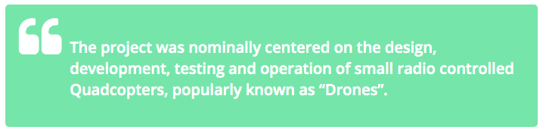

Example
http://www.thematic-learning.com/course/introduction/

